This document provides a UML diagram of project 1 along with test cases and screenshots. Additionally, this document provides lessons learned for this project.

UML Diagram:

Exceptions & Error

Class:   
ErrorHandle

Expression Evaluation

Class:  
Calculations

MAIN GUI

Class: CalculatorGUI

|  |  |  |  |  |
| --- | --- | --- | --- | --- |
| Test | Input | Expected | Actual | PASS / FAIL |
| 1 | * 2 + 2 - + 12 9 2 | Prefix to Postfix  = 2 2 12 9 + 2 - + * |  | PASS |
| 2 | +*/ | Error message | Error Message Displayed | PASS |
| 3 | 32+23-* | Postfix to Prefix = * + 32-23 |  | PASS |
| 4 | 125 / - 26 / 5 - * | Postfix to Prefix = *- 1/-26/5 |  | PASS |

Screenshots:

Test Case #1  
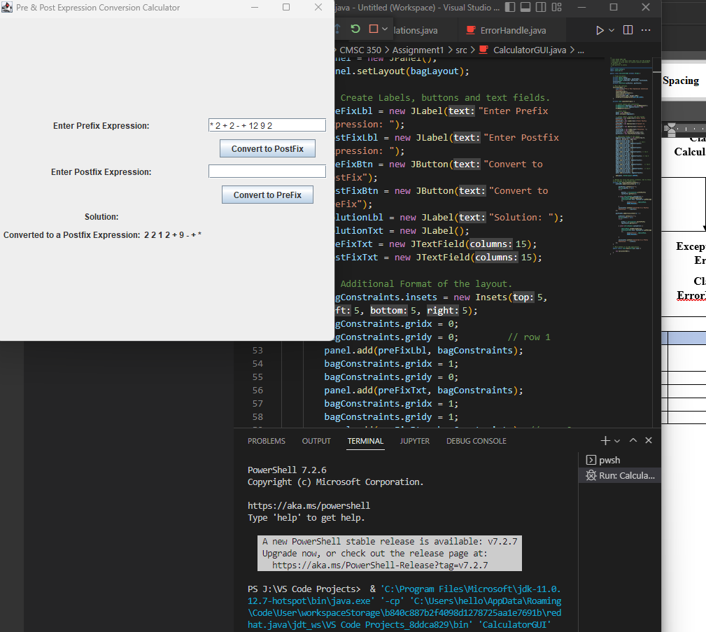

Test Case #2

Test Case #3

Test Case #4

Lessons Learned:

I learned a lot doing this project. Firstly, I read more about what UML diagrams are and how to make one. I tried to make one using Visio through UMGC web apps. Unfortunately, UMGC does not have the license for UML templates or the ability to use UML symbols or shapes. So I just made a diagram in Word. I also learned a lot more about stacks in Java. As well as building a GUI. I haven’t used Java or built a GUI in a while and it was a good refresher doing additional reading and practice.